**Mild to Moderate evaluation**

Sample_ID: **SVCBUG (CAT)**

Link: [https://app.animalbiome.com/pet/assessment/report /58d6e76c-4c51-4e07-bd36-a76b2a66f363](https://app.animalbiome.com/pet/assessment/report%20/58d6e76c-4c51-4e07-bd36-a76b2a66f363)

Mild to Moderate

Cats and dogs:

Any Two

(High Yellow Flag Megamonas OR (failed)

High Yellow Flag Sutterella OR (**passed**)

High Yellow Flag Collinsella OR (failed)

Low Yellow Flag Bacteroides OR (failed)

Low Yellow Flag Blautia (**passed**))

OR

Dogs: 8-10 Yellow Flags: 10 (**passed**))

OR 5-8 Red Flags: 1 (failed)

OR diet recommendation of increase fiber (failed)

OR diet recommendation of increase protein (failed)

OR diet recommendation of decrease carbs **(**failed) 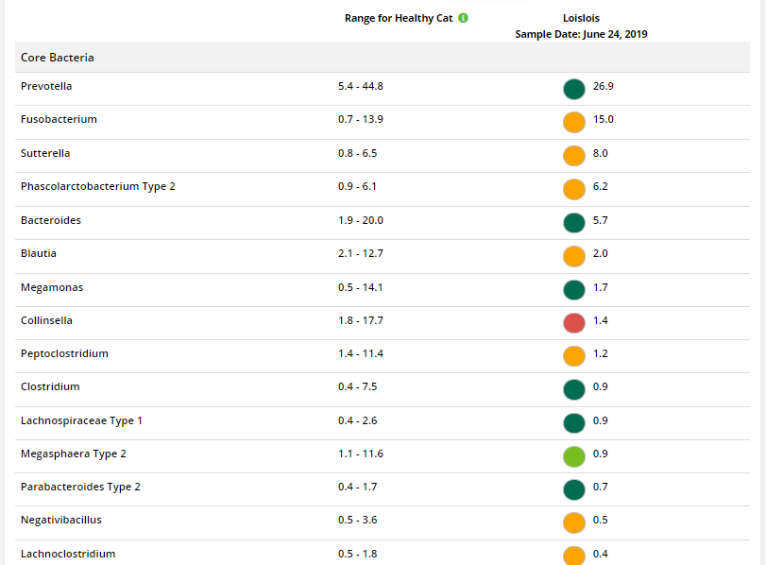 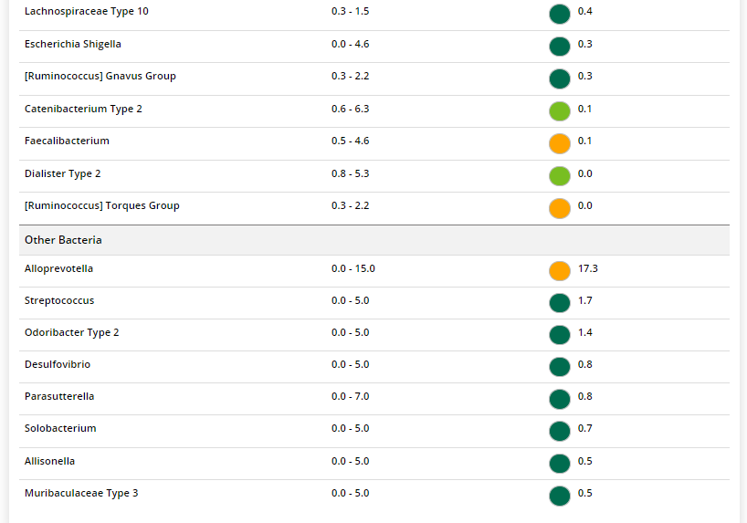



The result: **True True False False**

Expected result: Mild to Moderate

Achieved result: passed

